**Ganpat University**

**Faculty of Engineering & Technology**

**Computer Science & Engineerin0067**

***Name:- Dwij Vatsal Desai***

***Sem:- 2***

***Sub: - BOSS***

***Enrollment No.:- 23162121027***

***Prac:- 13***

**Practical 13**

1. Write a script to make following file and directory management operations menu based:
   1. Display current directory
   2. List directory
   3. Make directory
   4. Change directory
   5. Copy a file
   6. Rename a file
   7. Delete a file
   8. Edit a file

***Image:-***

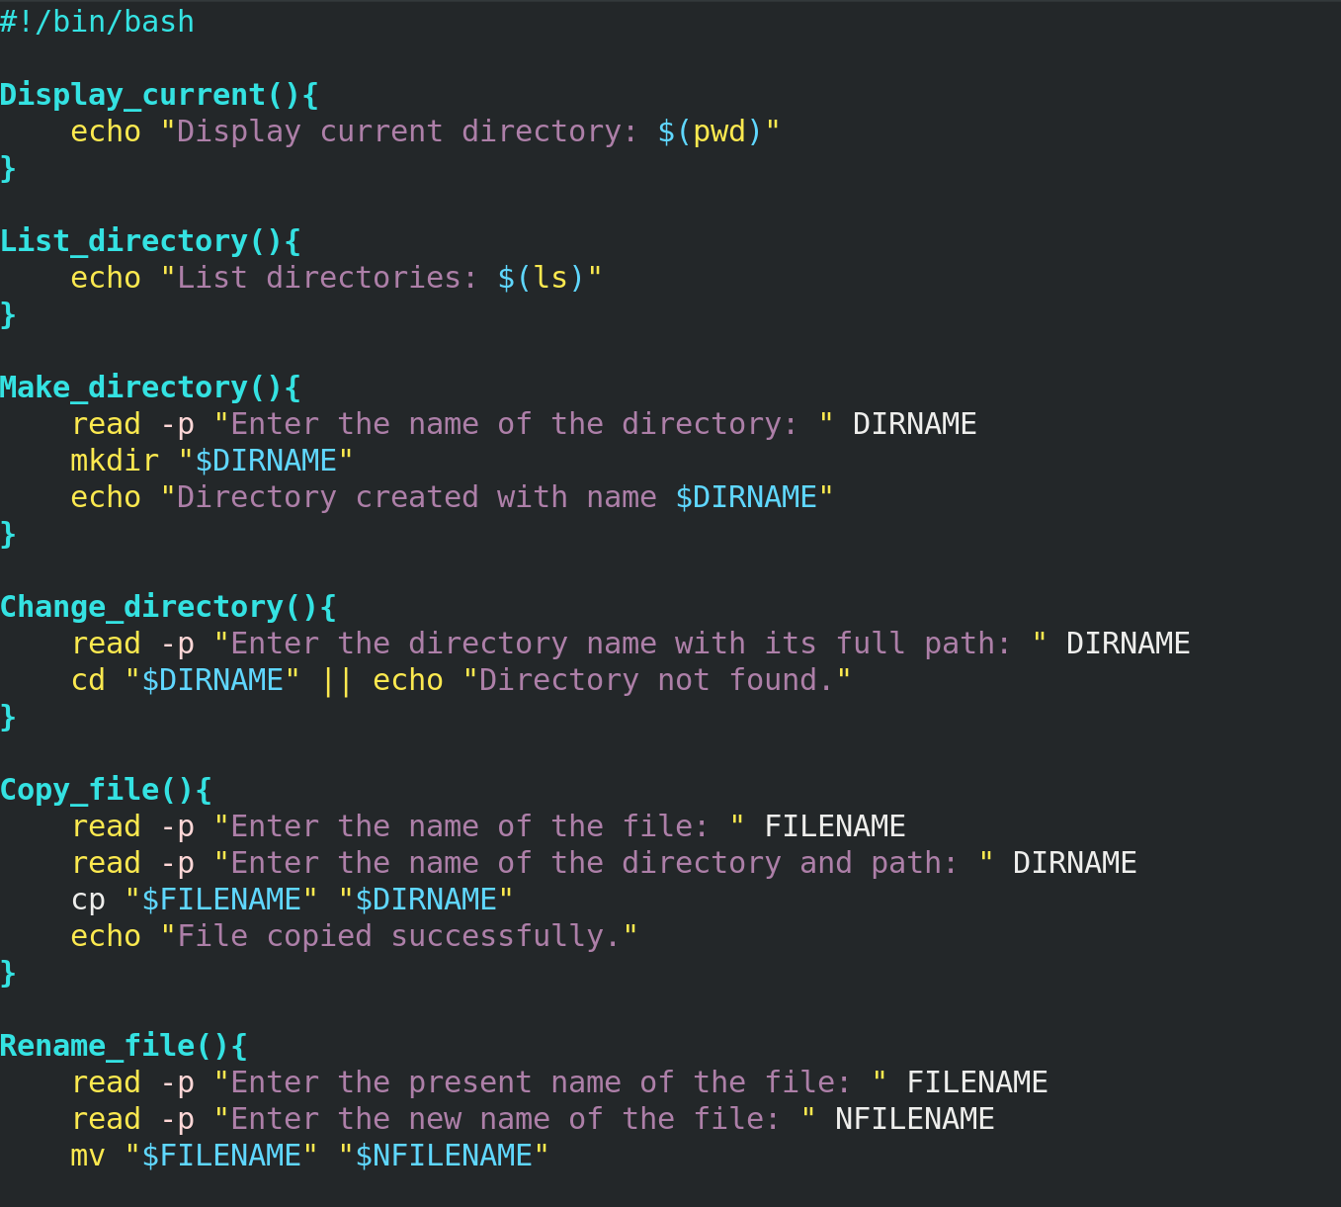 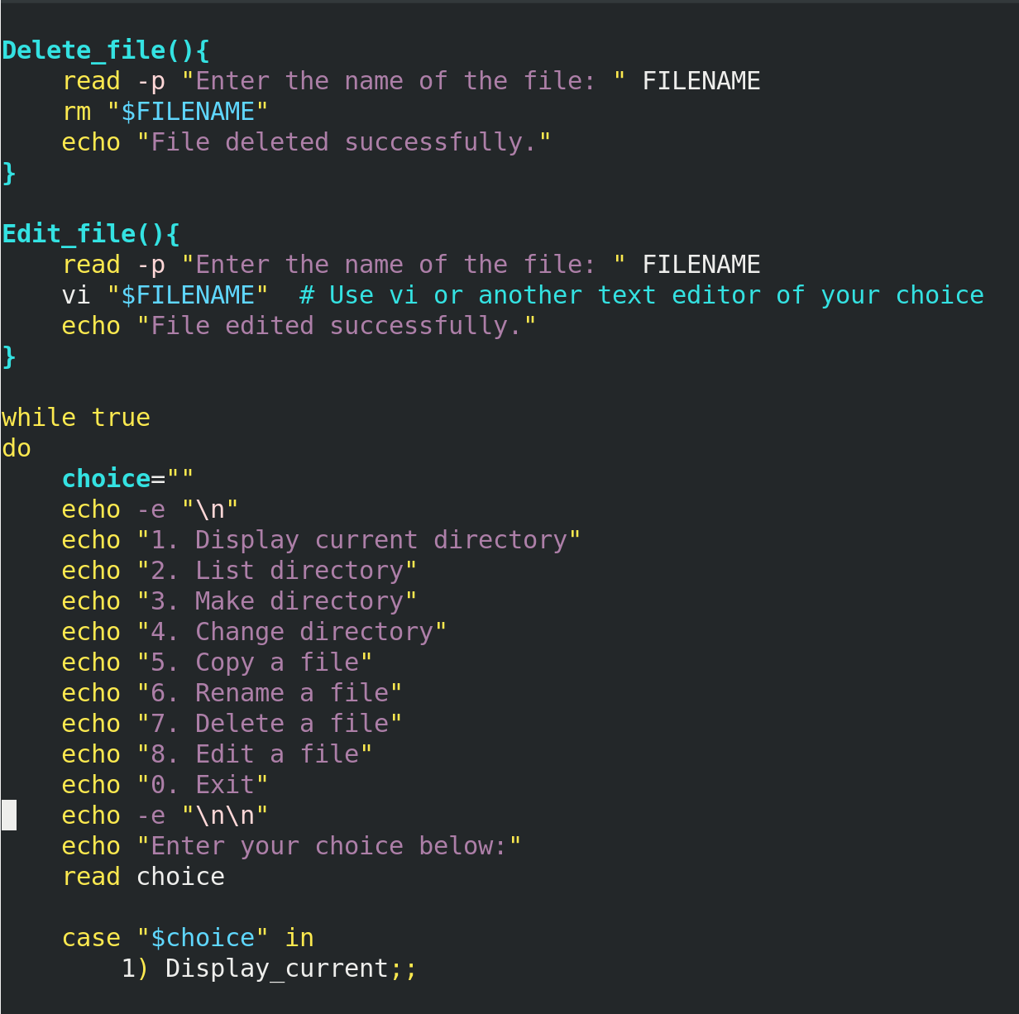

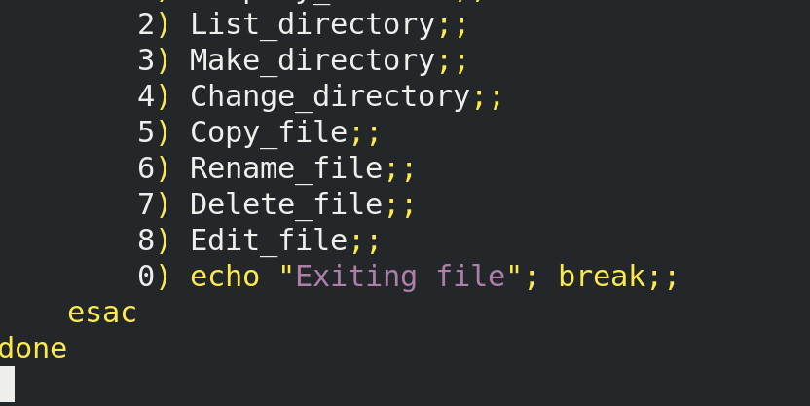

**Output:-**

